Student Dress Code & Where to Get Uniforms
Why uniforms?
- To strengthen a sense of belonging and ownership.
- To promote equity.
- To build habits of leadership.

Daily Appearance Expectations
TOPS: | - pilotED Schools logo  - No bare midriffs  - No cutoff sleeves
BOTTOMS: | - No sagging pants and/or exposed underwear  - Must be knee length or longer
BELTS | - Must be worn when appropriate  - No sparkles or metallic colors  - No large buckles
SHOES: | - Must be closed toed  - No heels  - No wheeled shoes of any kind
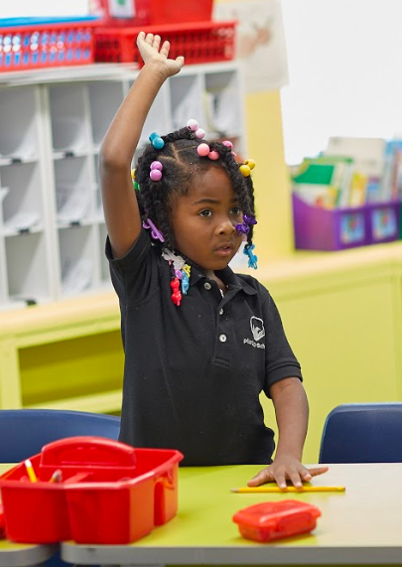
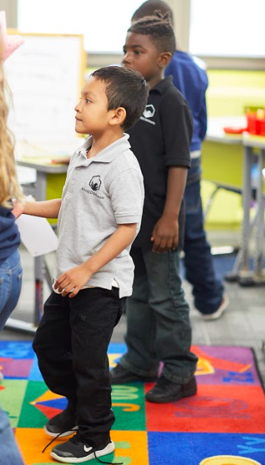

Grey and Black Polos – $13.99
Gym Shirts – Provided by pilotED
Sweatshirts – Provided by pilotED

pilotED has partnered with School Zone to complete polo purchases.

School Zone
(317) 253-7889
5425 N Keystone Ave #200, Indianapolis, IN 46220
MON – FRI: 10AM-7PM; SAT: 12-5PM; SUN: Closed

pilotED’s leadership team reserves the right to exercise discretion to make uniform changes or case-by-case uniform decisions throughout the school year to maintain an environment that supports school unity, professionalism, equity, and inclusion.

Spirit Days, Open Dress Days, and Other Events

pilotED Schools will, from time to time, have spirit weeks or days, where exceptions to the uniform policy will be made. For these days, the leadership team will provide specific guidelines about what dress is expected.

Accessories and Appearance Guidelines:
pilotED will use the following guidelines to determine acceptable types of accessories, shoes, jewelry, hair ties, headbands, etc.
- Safety and Security: Categorized by clothing deemed to be unsafe or unfit for day-to-day school activities (e.g open toed shoes), encouraging of violence, or gang-related behavior.
- Vulgarity and Inclusiveness: Categorized by clothing that is vulgar, supportive of drugs, alcohol, bigotry, sexism, racism, or otherwise offensive materials or messages
- Academic and Behavioral Distraction: Categorized by clothing that distracts from the attention of other students (e.g. jingling bracelets or earrings, blinking shoes, etc).

The guidelines below describe the school’s specific approved and otherwise not approved accessories and appearance. Because pilotED Schools cannot predict every situation, the pilotED staff encourages students to ask the school leadership when a situation is unclear.

Accessory | Approved | Not Approved
Earrings | Most earrings | - Flashing earrings  - Hoop or dangling earrings larger than ½ inch
Watches & Bracelets | Most watches and bracelets | - Bracelets that make noise  - Bracelets with spikes  - Bracelets with profane or vulgar writing  - Bracelet candy  - Apple Watches/FitBit (if they are deemed to be a distraction or used to violate other school policies)
Rings | Most rings | - Rings greater than the diameter of a nickel  - Ring Pops  - Rings with sharp edges or otherwise deemed dangerous
Headbands | 3 inches wide or less | - Bandanas  - Headbands that extend more than 1 inch off the head
Necklaces | Most necklaces  Necklaces that lie more than 1 inch past the collar must be tucked into shirt | - Candy necklaces  - Chokers  - Flashing necklaces  - Necklaces with profane or vulgar references on them
Hats | Provided by pilotED Schools  Cultural / Religious purposes | - Baseball caps  - Hats not for religious purposes
*pilotED Schools is not responsible for any lost or stolen accessories or clothing items that students bring to school.

Out of Uniform Consequences
When a student is out of uniform the school will work with the student and a family member to correct it.
- If a student cannot get in contact with a parent/family member to bring the appropriate uniform, the school will lend uniform clothing (of whatever size and fit is available). If the uniform item is not kept in good condition, then the family with be responsible for reimbursing pilotED Schools.
- Students frequently arriving out of uniform (more than 3 times) will have a parent or family meeting scheduled to discuss ongoing strategies to ensure the student follows the school uniform policy.
- If a student frequently changes their uniform throughout the day despite requests from staff to change it, consequences will be given by the Director of School Culture.

Exceptions to Uniform or Dress Code on Behalf of Religious Observances: pilotED Schools will recognize religious observances for students and work together with parents and students to adjust uniforms as needed. Parents must contact the pilotED School Principal or Director of School Culture to request accommodations. Parents are asked to make requests prior to the start of the school year.

