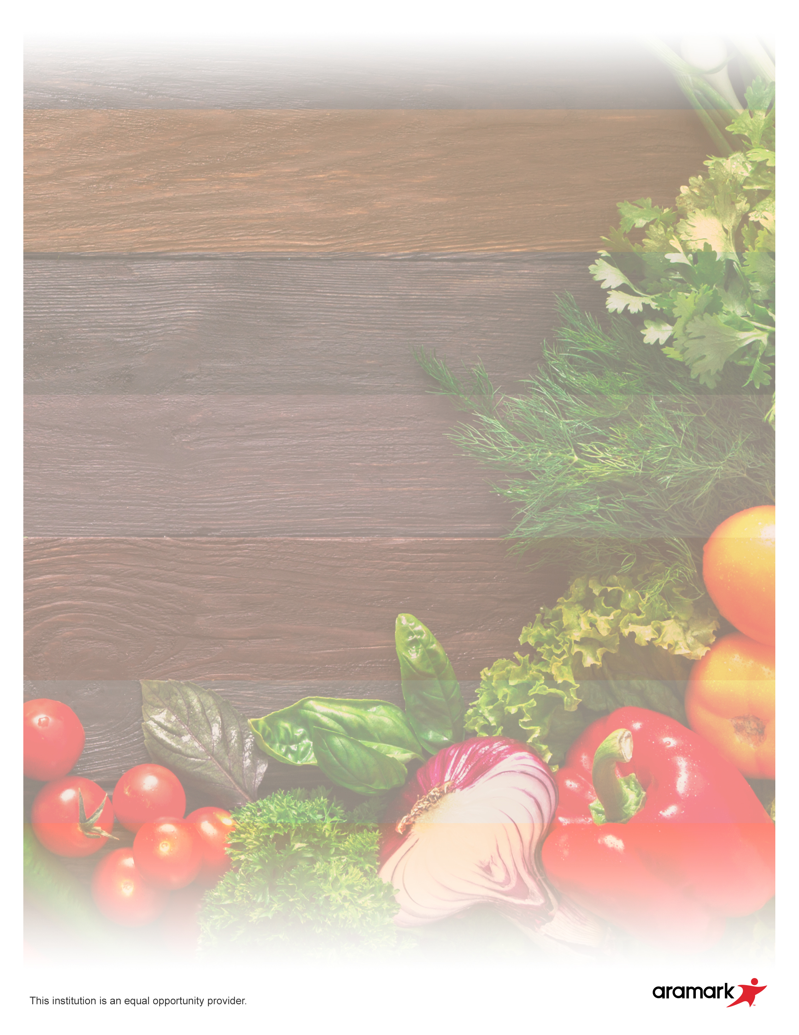

Beef Hot Dog

Fresh Carrots

Assorted Fruit

**16**

Cheese Quesadilla

Black Beans

Assorted Fruit

**17**

Meatball Sub

Veggie Blend

Assorted Fruit

**18**

Pepperoni Pizza

Broccoli

Assorted Fruit

**19**

Chicken Nuggets w/Roll

Potato Smiles

Assorted Fruit

**20**

Chicken Tenders w/Roll

Corn

Assorted Fruit

**23**

Beef Tacos

Pinto Beans

Assorted Fruit

**24**

Cheeseburger

Broccoli

Assorted Fruit

**25**

Corn Dog

Fresh Carrots

Assorted Fruit

**26**

Bosco Sticks &

Yogurt Cup

Green Beans

Assorted Fruit

**27**

Cheeseburger

Broccoli

Assorted Fruit

**2**

Burrito

with Sour Cream

Pinto Beans

Assorted Fruit

**3**

**1**

Beef Hot Dog

Celery

Assorted Fruit

**4**

Chicken Nugget

With Roll

Carrots

Assorted Fruit

**5**

Breakfast for Lunch

Hash Browns

Assorted Fruit

**6**

Chicken Drumstick w/Roll

Potato Smiles

Assorted Fruit

**30**

Crispitos

Baked Beans

Assorted Fruit

**31**

Grilled Chicken Sandwich

Broccoli

Assorted Fruit

**9**

Beef Nachos

Baked Beans

Assorted Fruit

**10**

Country Fried Steak

Carrots

Assorted Fruit

**11**

Cheese Pizza

Green Beans

Assorted Fruit

**12**

Turkey Burger

French Fries

Assorted Fruit

**13**

**Breakfast**

**Monday – Bagel w/Cream Cheese**

**Tuesday – Apple Frudle**

**Wednesday – Assorted Muffin**

**Thursday – Yogurt and Granola Bar**

**Friday – Cereal**

1% or Low Fat

**\*MENU IS SUBJECT TO CHANGE**

**PilotED Schools**

**August 2021**